Neuadd Ogwen, Ffordd Bangor, Bethesda Gwynedd, LL57 3AN
01248 208 850
post@neuaddogwen.com
Prif Neuadd & Gwybodaeth Cyffredinol // Main Hall & General Info

- Man Perffomio // Stage Performance area 6m x7m
- Gwagle llawr y Brif Neuadd // Main Hall er
- 380 Sefyll / Standing
- 168 Seti Symudol / Retractable Seating
- (gyda seddi ychwanegol/ with extra seating 200
- Wings 2m
- Load in / Out Dimensions: 1.8 X 1.8m
- Ystafelloedd Gwisgo / Dressing Rooms
- Drychau / Mirrors
- Toiled / Toilet
- Cawod ‘En Suite’ Shower (Dim toweli / No Towels)
- Mynediad o’r llwyfan yn unig / Accessible from the stage only
- Mae Wifi ar gael drwy’r adailad / Wifi is available throughout the building
- Mae’r adeilad yn addas i rhai sydd angen cadair-olwyn / The building is fully wheelchair accessible

Offer Technegol // Technical Equipment

Lighting

- Internally Wired Lighting Bars – IWB (All 15A sockets)
- 1 x 10M 12 way IWB with DMX - in Auditorium
- 2 x 3M 4 way vertical IWB - in Auditorium
- 2 x 9M 10 way IWB - above front & centre stage
- 1 x 9M 12 way IWB - above back stage

- Dimmers & Distribution
- LSC Redback 48 Way Dimmer
- Full patch system to IWBs

- Lighting Control
- 1 x ETC Smartfade 12/48 Lighting Desk
- Control room DMX input
- DMX Splitter
- DMX Patch Panel

- Lighting Fixtures
- 12 x LEDJ Slimline 229 LED par
- 8 x LEDJ Colour Storm Tri 1m LED Batten
- 6 x ETC Source 4 Jr Profile Spot

Additional Lighting

- Moving Heads installed on Trilite trussing over stage
- 6 x Coemar ProSpot 250 LX moving head
- 4 x Robe 250XT Wash moving head

- Moving Heads installed on Auditorium IWB
- 2 x Coemar ProSpot 250 LX moving head

- Control equipment for additional lighting
- 1 x Jester 24ML lighting desk
- 1 x Neutron Star XS haze machine

Projection System

- Screen
- 1 x 6M x 3.37M Electrically Operated Screen (16:9)
- 1 x Remote Controller

- Projector (Ceiling mounted in Auditorium)
- 1 x NEC PX750U WUXGA - 7500 Lumen Projector c/w 1.7 - 2.35:1 ratio zoom lens

- HDMI Stage link
- 1 x HDMI Link from front stage right to control booth

Cinema Sound

- Cinema System
- 1 x Blu-ray disc player
- 1 x Denon 7.1 Surround Sound Processor
- 7.1 Cinema speaker system

Production Sound

- Control Equipment
- 1 x Behringer X32 - 32 channel digital audio mixer
- 1 x Wireless access point (for iPad control) *excludes iPad
- 2 x Behringer S16 Stagebox in Flight Cases (16 input - 8 Return)

- Speakers
- 2 x JBL PRX618s Sub Speaker
- 4 x JBL PRX635 Mid/Top Speaker
- 4 x RCF 310A Monitor speaker

- Mics & Stands
- 4 x Sennheiser e835 vocal mic
Backline
3 Piece Mapex series drum kit incl. hardware.
Laney RB4 Bass Combo Amplifier (DI)
- 4 x Shure PG57
- AKG Drumkit mic set PG DR – 4
- 7 x Active DI box
- 10 x Tall Boom Mic stands
- 10 x Short Boom Mic stands
- XLR Cables

- Fixed Installation
- Stage connection panels – link to control booth panel (one on either side of stage):
  - 2 x XLR 3-pin Male
  - 2 x XLR 3-pin Female
  - 1 x RJ45 Ethercon

Llyniau / Photos

Golygfa o’r brif Neuadd o’r balcony technegol (Ddim yn cynnwys Goleuo Ychwanegol) /
A view of the main hall from the tech balcony (not including Additional Lighting)

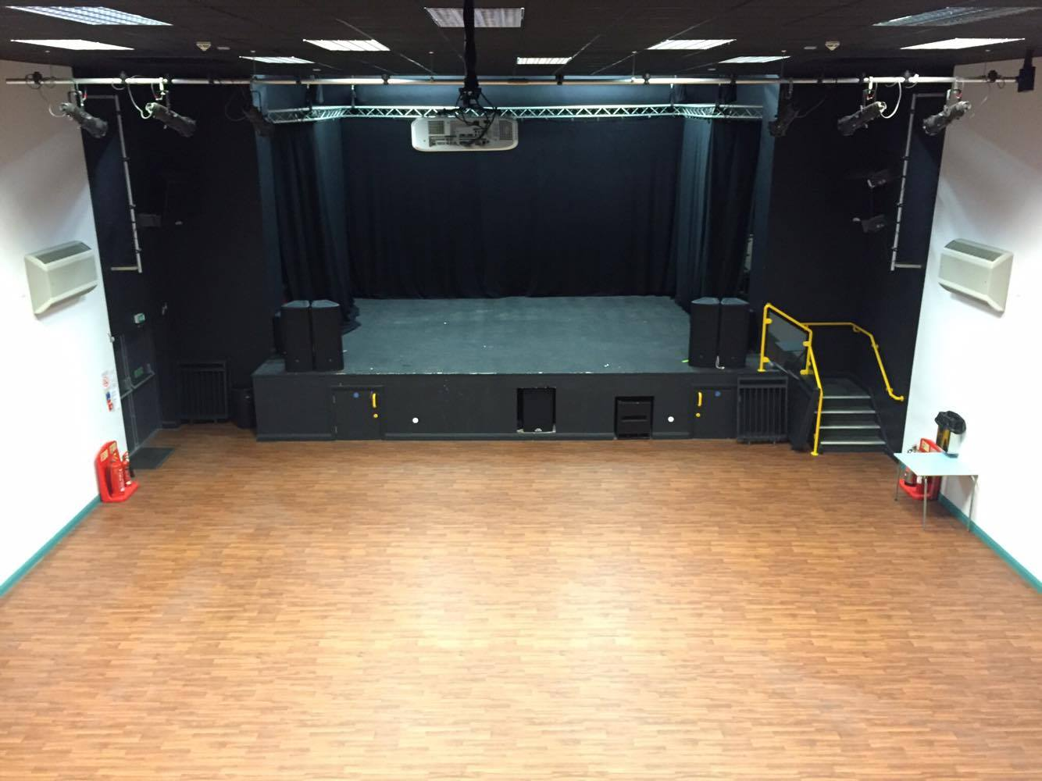

Edrych tuag at y llwyfan o cefn y Neuadd (Ddim yn cynnwys Goleuo Ychwanegol) /
Looking towards the stage from the rear of the main hall (not including Additional Lighting)

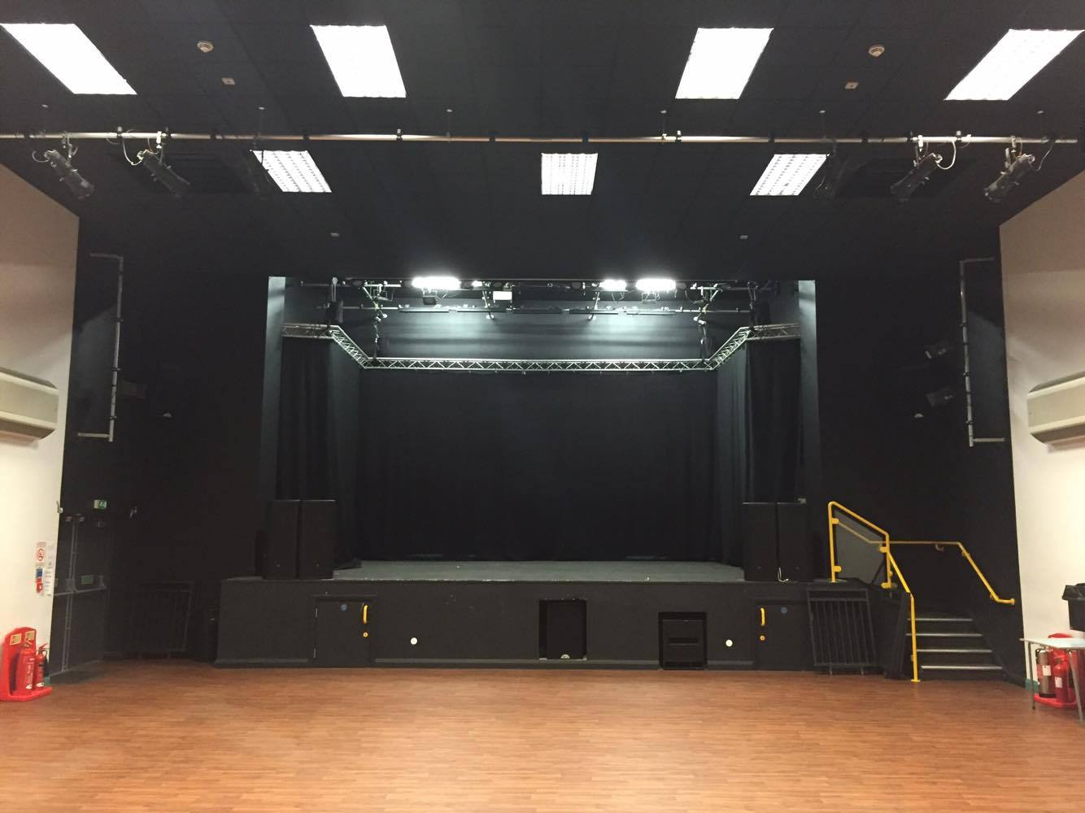
Golygfa o’r llwyfan allan (Seti I mewn) /
From the stage looking out (Seating Retracted)

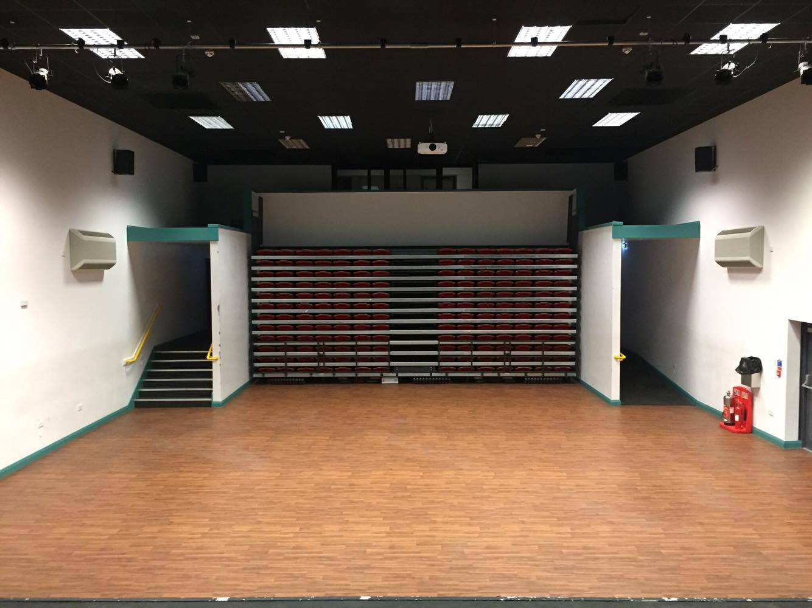

Seti allan / Seats out

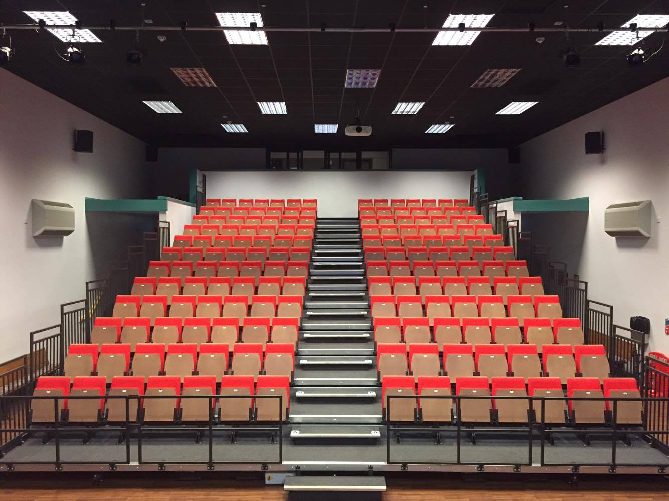

Stafell digwyddiadau llawr cyntaf /
First floor function room

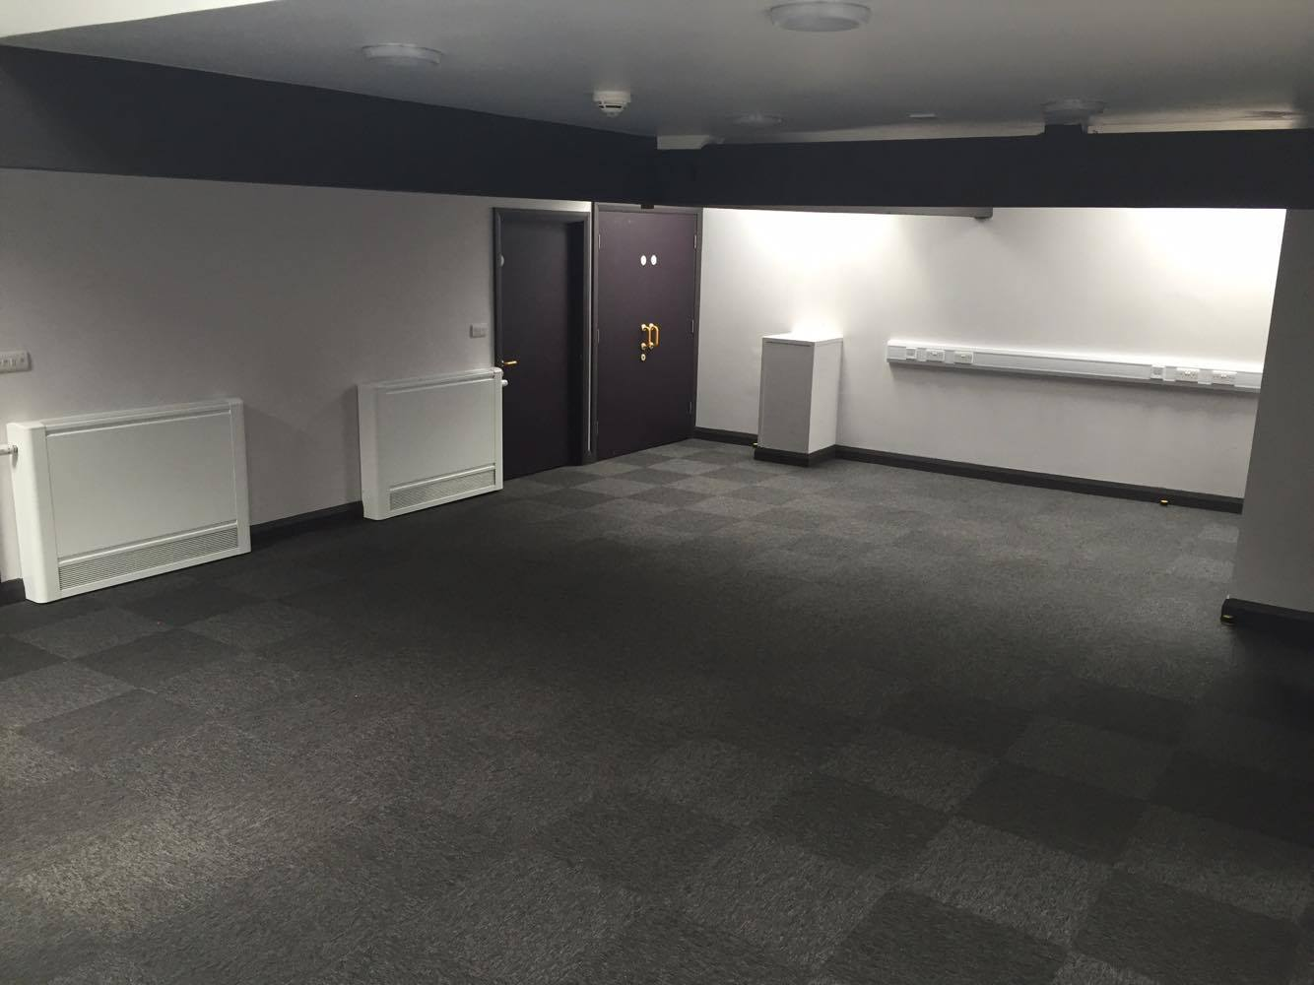

Neuadd Ogwen, Ffordd Bangor, Bethesda Gwynedd, LL57 3AN
01248 208 850
post@neuaddogwen.com

